# Racerstar Racing Edition 2306 BR2306S 2400KV 2-4S Brushless Motor For X210 X220 250 FPV Racing Frame

**Description:**

***Brand:*** Racerstar

***Item name:*** BR2306S 2400KV Brushless Motor

***RPM/V:*** 2400KV

***Height:*** 33.5mm

***Width:*** 28.5mm

***Shaft diameter:*** M5

***Motor mount hole size:*** M3

***Weight:*** 33.5 grams

***Voltage:*** 2-4S

***Battery:*** 2-4S lipo battery

***Internal resistance:*** Ω

**Usage:** X210 X220 250 280 FPV Racing Frame

**Tested with 14.8V voltage 5045 propellers:**

***Load current:*** 33A

***Pull:*** 980g

***Power:*** 458W

***Efficiency:*** 2.1 (g/W)

**Features:**

***Stainless steel motor shaft***

***Long life Japanese NMB ball bearings***

***Oxygen free copper wire***

***CNC machined aluminum case***

***More powerful than BR2205S***

[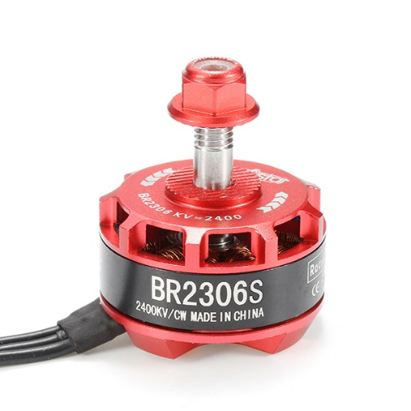](https://quadcoptersnp.com/wp-content/uploads/2020/10/d6207ac0-e304-428f-a0a8-9dbddccc027a.jpg)

# Tyto Robotics for Motor performance:

<https://database.rcbenchmark.com/motors/7dy/racerstar-br2306s-2400kv>

Haut du formulaire